EXPERIMENT – 1

ROLL NO : 240701433 NAME : RIYA SHARMA K

USER INTERFACE AND DESIGN
COMAPARSION OF UI DESIGN BETWEEN TWO FIGMA CREATION

BAD WEBSITE DESIGN :

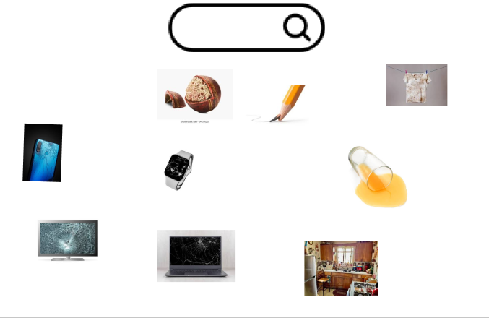

WHY IT’S BAD WEBSITE DESIGN :
1. Poor Visual Contrast
- The background and main product colors are very similar.
- This makes the product hard to notice and reduces its importance.
2. Dull and Unattractive Appearance
- The design looks plain and lacks visual appeal.
- There are no engaging elements like shadows, highlights, or decorative graphics.
3. Low User Engagement
- The “Contact Us” button is not clearly visible.
- Users may not know where to click or what action to take.
4. Weak Visual Hierarchy
- Important elements (product, text, categories) are not clearly separated.
- Everything looks the same, which confuses users.

GOOD WEBSITE DESIGN :

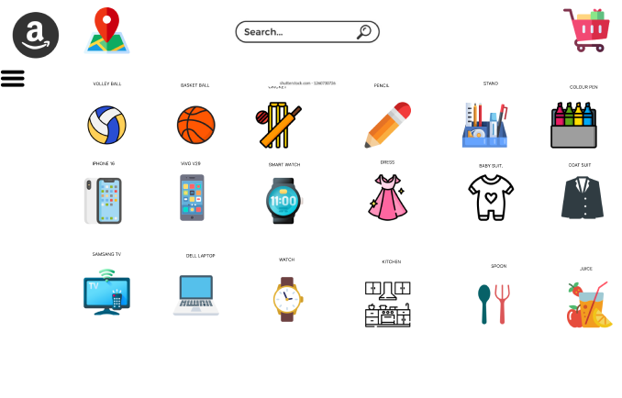

WHY IT’S A GOOD WEBSITE DESIGN
1. Strong Color Contrast
- The dark background makes the product stand out clearly.
- Text is easy to read and visually appealing.
2. Modern and Attractive Look
- Use of elements like plants, icons, and lighting improves the design.
- The interface looks more professional and visually rich.
3. Clear Focus on Main Content
- The main product is highlighted properly.
- The call-to-action button is easy to find and encourages interaction.
4. Effective Visual Hierarchy
- Content is well-organized into sections (header, main area, categories).
- Users can quickly understand where to look first.
5. Better Spacing and Alignment
- Proper spacing makes the design clean and easy to navigate.
- Elements are neatly arranged, improving readability.

